31.36: a) 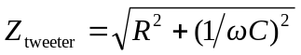
b) 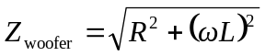
c) If 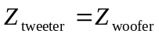, then the current splits evenly through each branch.
d) At the crossover point, where currents are equal:


